**Regular Expression Practice Questions**

Question 1- Write a RegEx pattern in python program to check that a string contains only a certain set of characters (in this case a-z, A-Z and 0-9).

Ans

Question 2- Write a RegEx pattern that matches a string that has an a followed by zero or more b's

Question 3- Write a RegEx pattern that matches a string that has an a followed by one or more b's

Ans

Question 4- Write a RegEx pattern that matches a string that has an a followed by zero or one 'b'.

Ans

Question 5- Write a RegEx pattern in python program that matches a string that has an a followed by three 'b'.

Ans

Question 6- Write a RegEx pattern in python program that matches a string that has an a followed by two to three 'b'.

Ans

Question 7- Write a Python program that matches a string that has an 'a' followed by anything, ending in 'b'.

Ans :

Question 8- Write a RegEx pattern in python program that matches a word at the beginning of a string.

Ans :

Question 9- Write a RegEx pattern in python program that matches a word at the end of a string.

Ans - Import re

pattern = “python programming|Python programming”

text = “Python is a case sensitive language”

matches = re.findall(pattern , text)

print(matches)

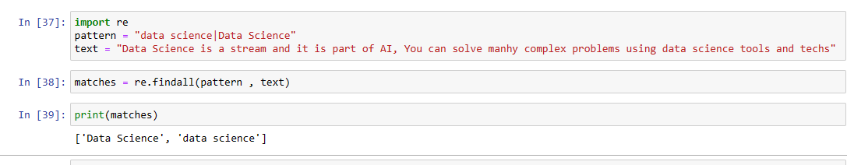

Question 10- Write a RegEx pattern in python program to find all words that are 4 digits long in a string.

Sample text- '01 0132 231875 1458 301 2725.'

Expected output- ['0132', '1458', '2725']

Ans : pattern = “\d+”

text = “There are 123 Mangoes and 4567”

matches = re.findall(pattern , text)

print(matches)